**Car Machines Modeling Journal :**

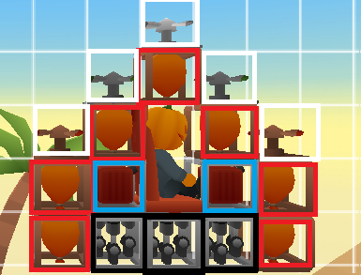

* D13 : Fast Rocket with 7 balloon blocks, 2 wooden propellers, 2 stone propellers, 1 iron propeller, 3 V3 engines, 2 V3 fuel blocks.

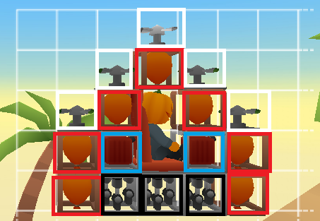

* D14 : Fast Rocket with 7 balloon blocks, 4 stone propellers, 1 iron propeller, 3 V3 engines, 2 V3 fuel blocks.